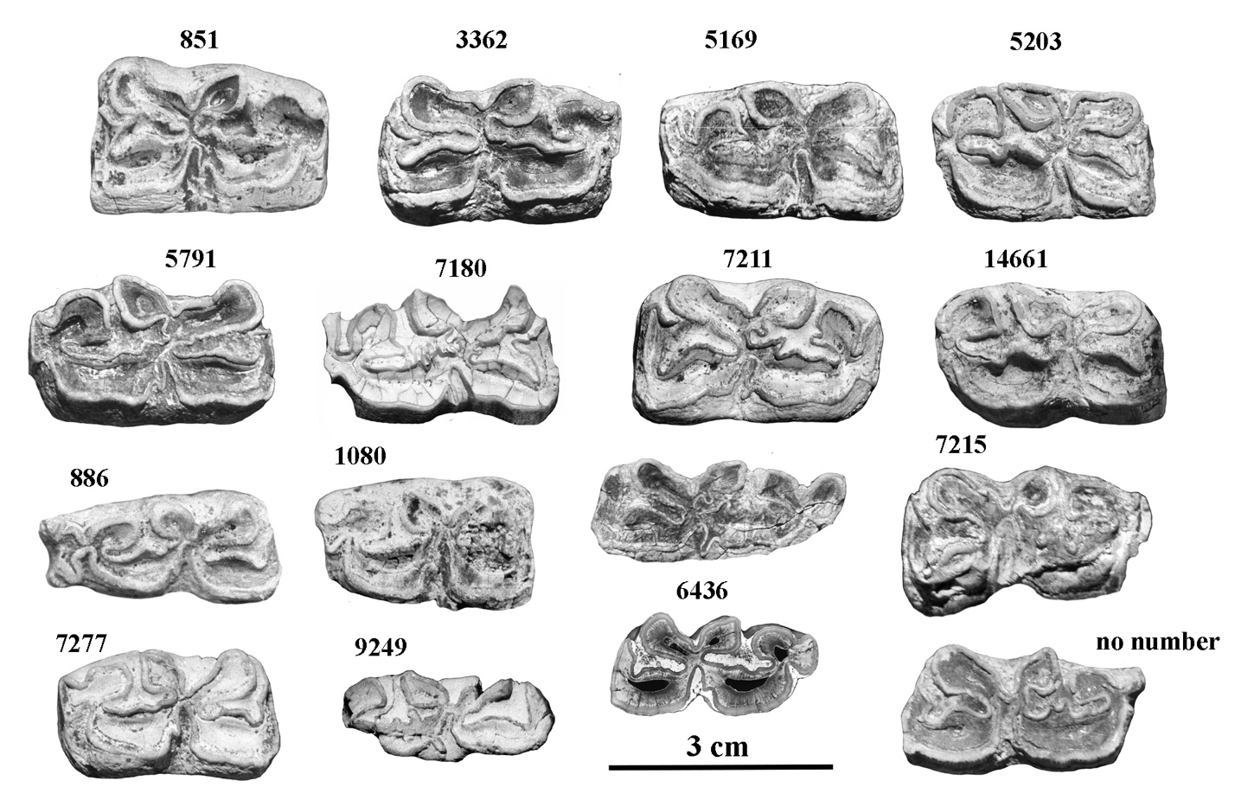

Figure S19. Occlusal views of lower cheek teeth of *E. marxi*. All the accession numbers should be prefixed by IQW S. IQW S 851 to 14461: Premolars. IQW S 886 to no number: Molars.